9 DAYS 8 NIGHTS MYANMAR EXPLORER
Our tour started with a drive through the bustling streets of Yangon. Our lunch venue was at the majestic Karaweik Palace restaurant, housed in a 2-storey building with a traditional palatial design, constructed on the Kandawgyi Lake. We had a taste of traditional Myanmar cuisine in a unique architectural setting.
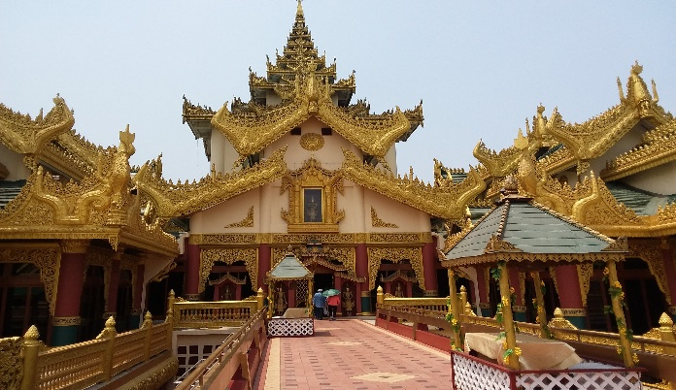
In the afternoon, we visited the Shwedagon Pagoda, with gold plated spires shimmering in the setting sun.
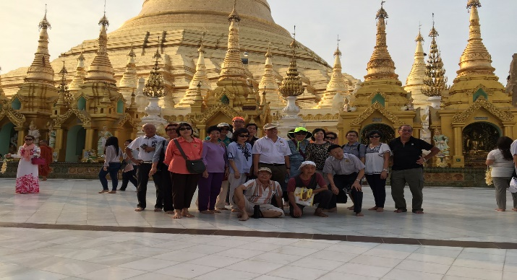
The next day, we took a short flight to Bagan, the land of over 2,000 Buddhist monuments. It lived up to its reputation as one of the most beautiful Buddhist archeology sites. The endless numbers of religious monuments dotted the flat plain, making it a major tourist attraction. From a vantage point close to our hotel, it was a sight worth seeing in the early hours of dawn, as the sunlight casts its rays over the numerous stupas and temples scattered all over the plain.
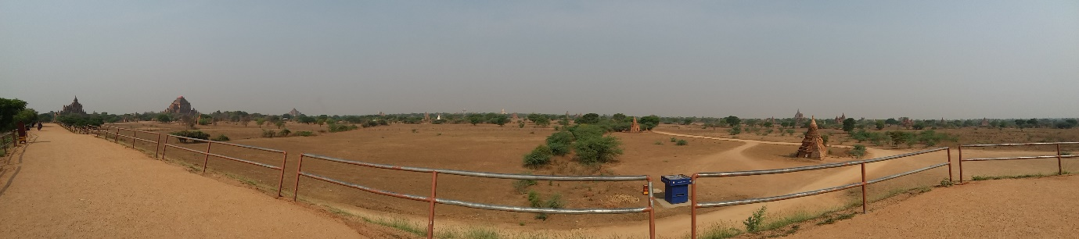
We also visited the marketplace where we saw many stalls selling local vegetables and meat and a lacquer factory.

The tour at Bagan ended with a dinner served in a garden setting, with a traditional Myanmar Puppet Show being performed on the stage.
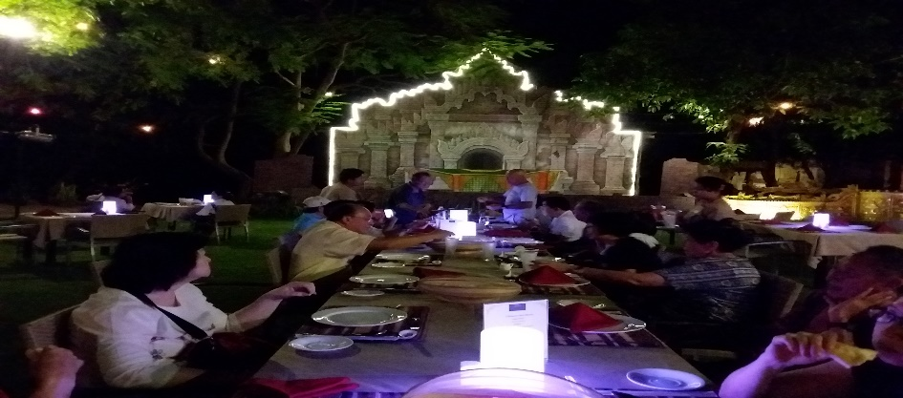
We departed from Bagan by coach and reached Mandalay, another famous city in Myanmar and a capital city of old. The highlights of Mandalay are as follows:
Mandalay Hill – A panoramic view of the city could be seen from the top of the hill, accessible via an unforgettable motor car ride up the narrow and winding road.
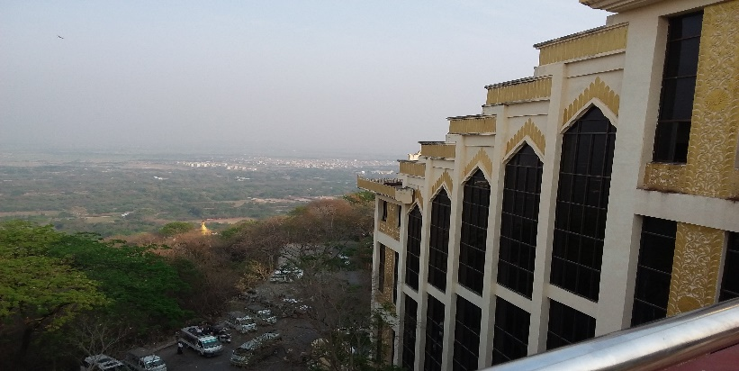
Kuthodaw Pagoda – it contains the largest book in the world comprising of hundreds of marble slabs with text of the Tripitaka inscribed on it.
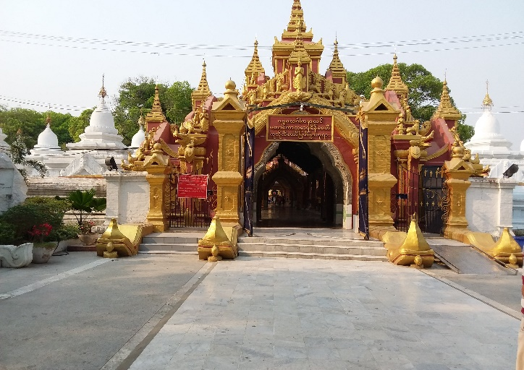

Mingun Pahtodawgyi Temple – a gigantic incomplete stupa with a 50m height which was so massive, it could be seen from afar.
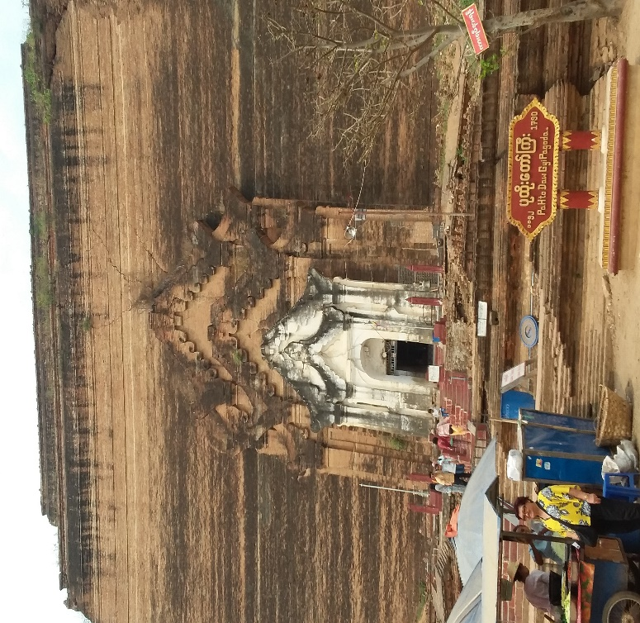
Mingun Bell – a huge bronze bell said to be the largest ringing bell in the world.
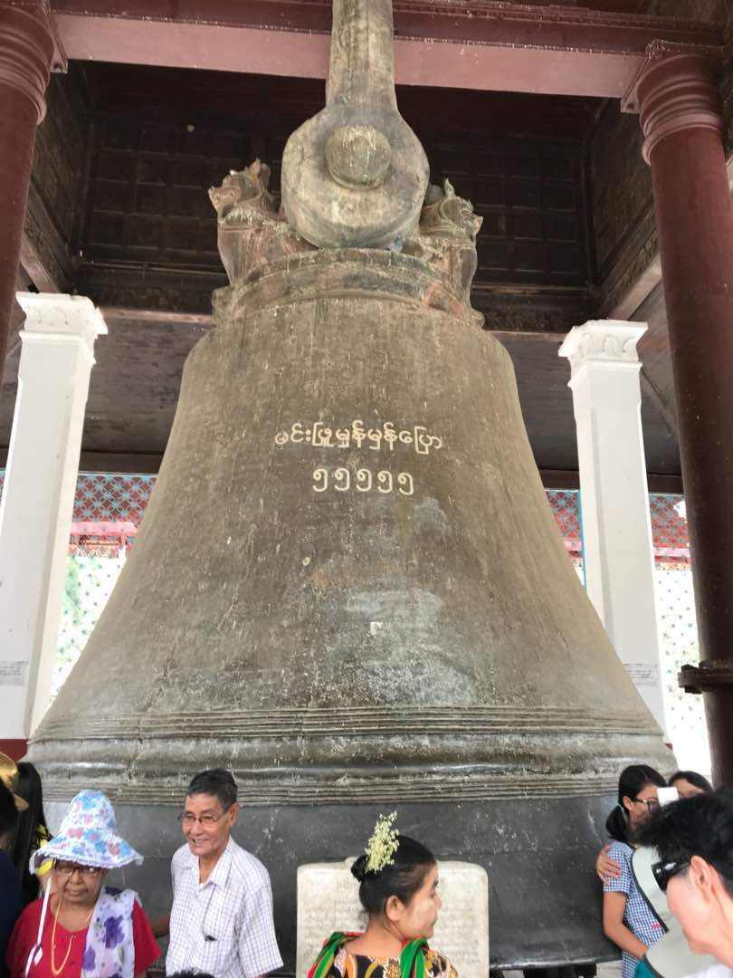
Hsinbyume Pagoda – Unique pagodas all in a white colour.
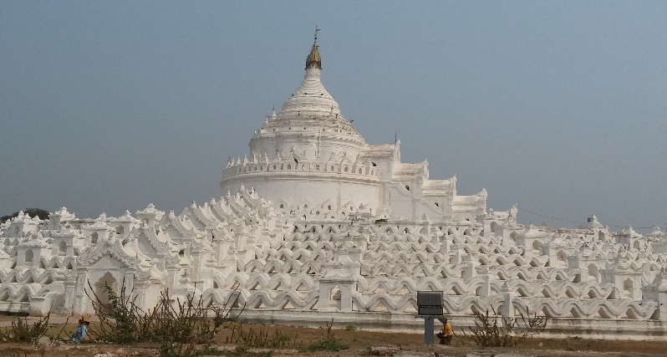
Teak Bagaya Monastery – Built on over 200 gigantic teak wood posts with great dimensions in the middle of a paddy field.
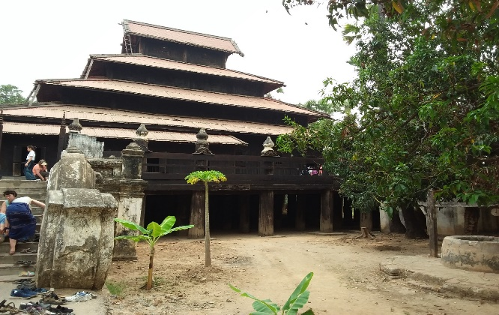

Maha Aung Mye Bonza Monastery – The brick monastery with ochre colour, making it different from others.
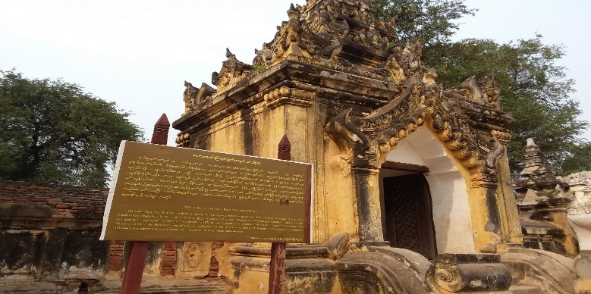

Pony Ride – through the scenic villages of Mandalay
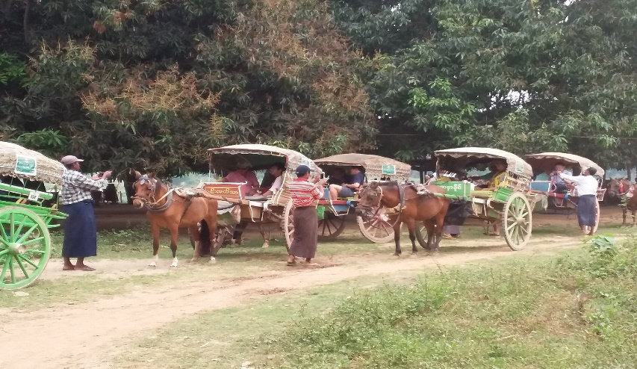
U Bein bridge – Not to be missed landmark spanning the Taungthaman Lake, this 1.2km long bridge is believed to be the oldest and longest teak wood bridge in the world made with about 1086 teak pillars.
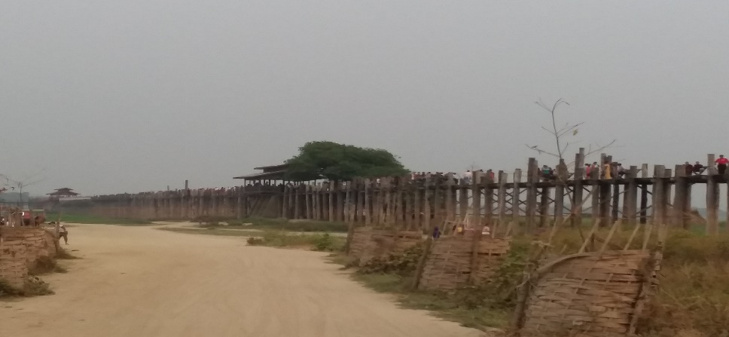
Gold Leaf Factory – We were shown the traditional method of making gold leaf, which requires great physical effort and lots of time.
Next Stop – Inle Lake, Myanmar’s 2nd largest fresh water lake in the Shan State. A “must-see” destination, the lake is surrounded by many marshes, floating vegetables, gardens, houses and temples on stilts. We saw the fishermen rowing their boats with their unique one-legged rowing technique. Stops were made at the lotus and silk weaving factory, cheroot factory, boat building place, umbrella workshop. We had a relaxing stay at the Best Western Thousand Island Hotel situated on the banks of a river, with scenic views of the river, the sunrise and the sunset.
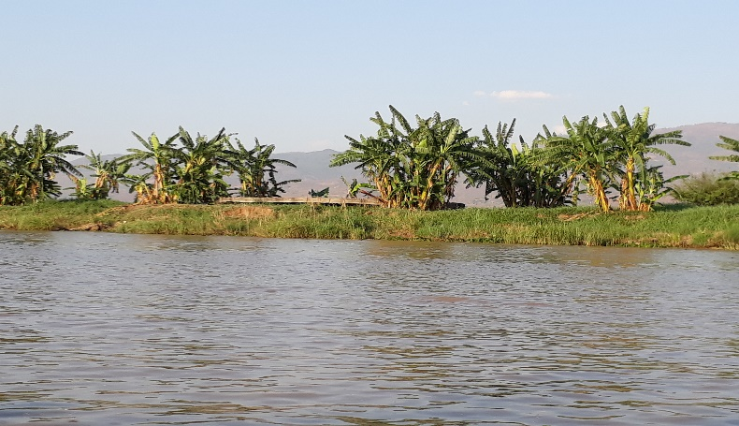

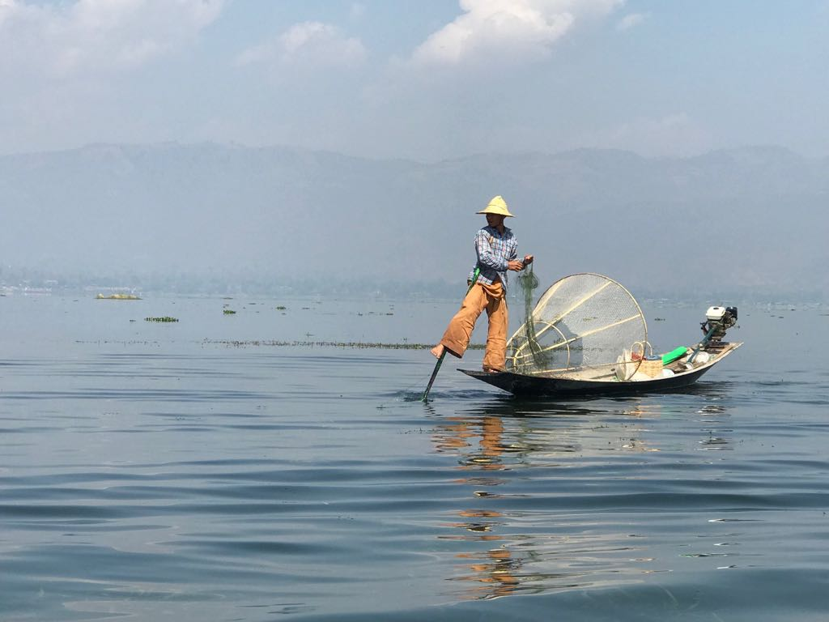
No trip would be complete without some shopping and our tour ended with a visit to Scotts Market, which sells souvenirs, gold, jade, precious stones, local food, clothes and religious items, giving everyone a last-minute shopping opportunity. Apart from the many sightseeing places, we also experienced the warmth and hospitality of the Myanmar people that will always remain in our memories

