6 DAYS/5 NIGHTS PAI in THAILAND
JAN 11-16, 2024

The best time of year to go to Northern Thailand is January, the so-called Thailand “winter”, which has the best climate you can get. Especially in Pai, daytime will be nice and sunny, with maximum temperatures averaging around 26C, while evenings are considerably cooler (13C).

6 Days 5 Nights CHIANG MAI – PAI
Singapore – Chiang Mai:  TR674 11 JAN | Chiang Mai - Singapore  TR677 16 JAN
Day 1: 11 JAN: ARRIVAL AND WELCOME TO CHIANG MAI OVERNIGHT AT MAE TEANG  - Depart from Changi Airport T2 for Chiang Mai on Scoot  - Meet on arrival @ Chiang Mai International Airport  - Transfer to Thapae gate and enjoy a fresh coconut ice cream treat as we get to know Chiangmai by EV TukTuk (Electric vehicle) of the old city quarter with its old walls and moat.  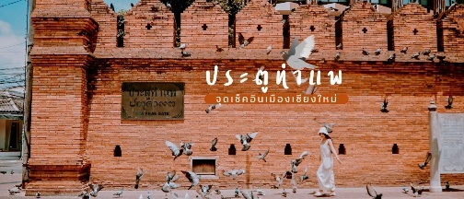  - Then transfer to hotel for check-in. Dinner is served @ local popular restaurant  08.00 pm Rest and be prepared for our programme to Pai |  | Light Meal on Board  Dinner: Tolou Chinese Restaurant
Day 2 12 JAN CHIANG MAI – PAI (3 HRS)  07.30 Breakfast at hotel. Check out at 0900hrs and board our vehicle.  09.00 Transfer to Pai, the name of a small mountain town in Mae Hong Son, famous for its idyllic natural scenery and laid-back bohemian vibe. Pai is surrounded by picturesque mountains, lush green valleys, and serene countryside, making it an ideal destination for nature lovers and photographers.  12.00 Arrive Pai and enjoy lunch at a local Thai restaurant.  - visit the Pai Memorial Bridge and Santichon Yunnanese village  17.30 Later we visit.  - Pai Canyon: Also known as Kong Lan, Pai Canyon offers breathtaking views of the surrounding  landscape and is a popular spot for hiking and watching the sunset.  - Pai Walking Street: The town's main street comes to life in the evening with a vibrant night market offering local handicrafts, delicious street food, and live music performances.  Refreshment point @ Coffee in Love. Enjoy famous Pai walking street.  Overnight at Ai Pai Resort for 3 nights |  | Breakfast: resort  Lunch: Mittaphap Pai.  Dinner: Ban Pai
DAY 3 13 JAN: PAI – PANG MAPHA EXCURSION (2-3 HRS.)  07.30 Breakfast at resort before we start the day to Pang Mapha District of Mae Hong Son.  07.45 Enjoy a 360⁰ view across the mountains and valleys below at Kiewlom Viewpoint and then visit the Black Lahu village of Baan Ja Bo , for the stunning viewpoint and perhaps enjoy a popular local noodles and coffee.  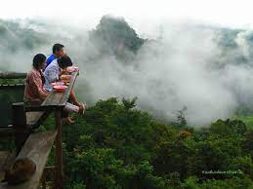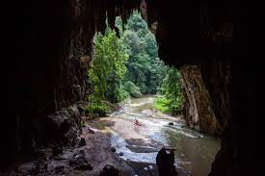  09.30 Visit Tham Nam Lod, also known as Tham Lod Cave, a well-known natural attraction located in the Pang Mapha district of Mae Hong Son Province in northern Thailand. It is one of the most impressive and extensive caves in the region due to its stunning formations and historical significance. Inside the cave, you can marvel at breathtaking stalactites and stalagmites, impressive rock formations, and large caverns with unique shapes, textures, and sizes. We explore Lod Cave with a bamboo rafting experience along the underground river that flows through parts of the cave. The rafting journey allows you to access deeper sections of the cave while enjoying the serenity of the surroundings.  Next we visit Sai – Ngarm Hot Spring and enjoy a foot therapy. Then transfer back to Pai for dinner at local restaurant. Back to our resort to rest. |  | Breakfast: resort  Lunch: Keaw Mora  Dinner: Horm Muen Lii
Day 4 14 JAN: PAI  08.30 Breakfast at hotel.  09.00 Depart for Kho Ku So Bridge, Shan village visit, the wooden bridge was created by the local people and dedicated to Buddhism. Shan Style temples and architecture can be found only in the Pai area.  Visit Pai Waterfall and enjoy a sunset view from Wat Phrathat Mae Yen before returning to town.  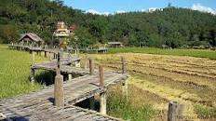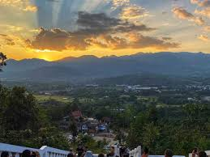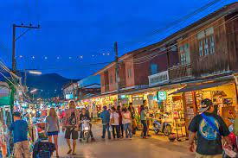  Dinner at a local restaurant and rest at the hotel or explore the walking street |  | Breakfast: hotel  Lunch: Chelee & Lek  Dinner: local Thai restaurant
Day 5: 15 JAN: PAI - CHIANG MAI  Breakfast at resort, check out and transfer back to Chiang Mai.  - Lunch at a popular local restaurant (Neng Earthen Jar Roast Pork)  - Check into Rain Tree Hotel and free at leisure until dinner at Michelin Guide Huan Soontaree, a popular riverside restaurant, made famous by the popular “Sao Chiang Mai” song.  - This evening, enjoy some leisure shopping time at the famous Night Bazaar  - Return to hotel to rest and overnight.  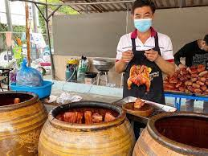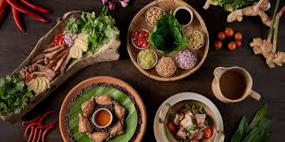 |  | Breakfast: hotel  Lunch: Neng Earthern Jar  Dinner: Huen Soontaree
Day 6 16 JAN: CHIANG MAI – SINGAPORE  Breakfast at the hotel and check out. Transfer to Chiang Mai International Airport for departure. Arrive Singapore later this afternoon. |  | Breakfast: hotel  Light Meal on Board
NB: Choice of restaurants and routing may change in the event of closure due to prebooked events or uncontrollable conditions and shall serve as a guideline only.

Flight Details
TR674 11JAN Thu Singapore/Chiang Mai Dep 1445hrs Arr 1640hrs
TR677 16JAN Tue Chiang Mai/Singapore Dep 1200hrs Arr 1610hrs

6D/5N PAI THAILAND  Price | Twin Sharing PP  Member | Twin Sharing PP  Non-Member | Single  Member
Pai: Ai Pai Resort – 4 star (3 nights)  Chiang Mai: Rain Tree Hotel – 4 star (2 nights) | $1,680.00 | $1,760.00 | $1,920.00

Price includes:
- Return group airfare Singapore/Chiang Mai/Singapore on Scoot with 20kg check in baggage and meals
- Airport transfers
- Charter vehicle transportation by minibus (outside Chiang Mai city) with bottled drinking water
- 4-star hotel accommodation with breakfast (5 nights)
- All lunches and dinners where stated
- Service of experienced tour manager, guide and drivers
- Tipping for guide and drivers
- All admissions where required
- All local taxes

Price does not include: Personal incidentals, travel insurance

CLOSING DATE: 01 Dec with non-refundable deposit or when tour is full. Limited to 20 places max only!

