***8 DAYS/7 NIGHTS EAST RIFT VALLEY TAIWAN***

*20-27 Feb 2024*

*Eastern Taiwan is nature’s playground with views all around and unique activities that are hard to find elsewhere. Take the road less travelled and enjoy the quieter East Rift Valley of Taiwan!*

**Day 01 Singapore – Taipei** on SQ878 1125/1620hrs (meal on board, D)

Arrive Taipei and transfer to city for dinner. We check into our hotel for overnight to recharge or explore around the hotel (The Place Nangang or similar)

**Day 02 Taipei – Yilan** (BLD)

Breakfast at hotel. We check out and journey to **Yilan** (1 hr) located in the central and most favored part of the Lanyang Plain. Streams and rivers provide a constant source of replenishment for the nutrients in the soil here, making Yilan a breadbasket county. A full day of sights awaits. Established in 2005, **Kavalan** is Taiwan’s first whisky maker and the nation’s only family-owned whisky distillery. Kavalan takes the old name of Yilan county. Pure water and fresh air make this part of the subtropical island the ideal environment for the production of whisky.

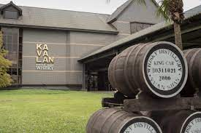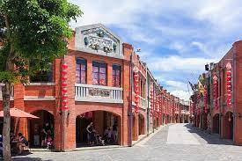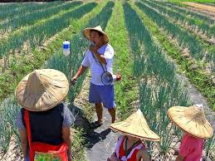

Walking into the park at the **Center for Traditional Arts** makes you feel like falling into a time tunnel. The streets decorated with red walls and black tiles are blended with the architectural styles of the old streets everywhere in Taiwan. All sorts of special stores, such as workshops and early Taiwanese variety stores, stand along the streets. Here, you may see things that trigger the fun memories of your childhood, such as dough figurine sculptures, sugar onion, traditional toys, glove puppetry, etc.

Try your hand at being farmers in picking and planting scallion, as well as making **scallion pancakes** which are delicious, fun and make for great pictures. We check into our hotel after dinner (Lakeshore Hotel Yilan or similar)

**Day 03 Yilan – Taitung** (BLD)

After breakfast at hotel, we head for Taitung by taking a **train ride** to Chishang. We head to **Mr Brown Avenue** in Chishang Township to be surrounded by nature. Known for its idyllic golden rice fields, Chishang is the postcard picture of a quaint small town. Paradise Road is also connected to Mr Brown Avenue and looks like a never-ending path leading straight to the lush mountains. Cutting through the middle of the rice fields, explore safely on an **electric family bike** (4 per vehicle – 1 hr) to fully enjoy the views. This evening, enjoy our dinner at an **Aboriginal Restaurant** with Live Singers before we check into our hotel for 2 nights (Naruwan Galaxy Hotel Resort or similar)

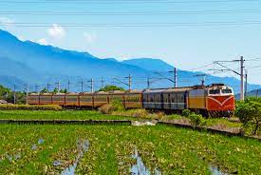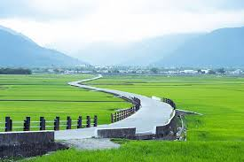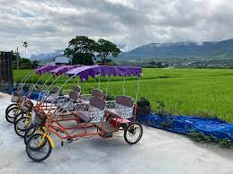

**Day 04 Taitung** (BLD)

Breakfast at hotel. The **Luanshan Forest Culture Museum** is situated in this lush forest that is a treasure trove of indigenous culture and natural beauty. On this half-day tour of the Luanshan Forest Culture Museum, you can get an understanding of how the Bunun lived in harmony with Mother Nature as well as the wisdom the Bunun have of coexisting with their natural environment. After an authentic Bunun meal, we visit **Chulu Ranch**, situated 200 m to 390 m high above sea level, is the largest slope ranch with 70 hectares. Follows the **Taitung Historical Rail** that has been transformed into a band-shaped green area and cultural space since 2001 to enjoy the beautiful natural views and cultural spaces before a buffet dinner time!

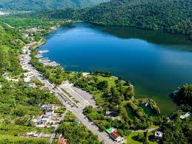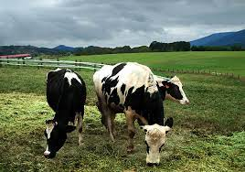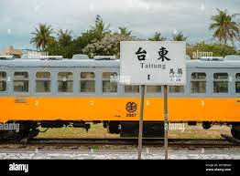

**Day 05 Taitung – Hualien** (BLD)

This morning, we visit the **Amis Folk Center** that focuses on the Amis people—the largest number of indigenous tribes in the East Coast—as the theme. Whether its architecture, exhibitions or performances all contain Amis cultural features. Through Amis material culture, music and cuisine, travelers can feel the meaning of life demonstrated by this indigenous tribe living on the ocean. We then visit **Sanxiantai** which was once a narrow and elongated cape into the ocean. When the neck of the cape was eroded by the tide, the rest of the cape was disconnected with the land and became an island. It is said that three gods, named Li Tieguai, Lu Dongbin and He Xiengu visited here and left three pairs of footprints. After lunch we journey to **Hualien** (3 hrs). Enroute we stop over at **Shoufeng** and visit **Hayaku** where we aregreeted with an amazing view of the **Pacific Ocean**, with unblocked view while enjoying your cup of coffee or dessert. Walk around the park and explore. Also the entire area is free sitting if you want to just have a good tea while soaking in the surrounding views. We arrive in Hualien and check into our hotel for 2 nights. This evening, after dinner, we explore the lively **Dongdamen Night Market** and immerse ourselves in local Hualien “nightlife”. With an enormous amount of food on offer and the variety you can sample, it is an easy place to get a unique, taste of Taiwan. Along with food, you will find entertainers including singers, guitarists, drummers, dancers and more. Back to hotel to rest (Lakeshore Hotel Hualien or similar)

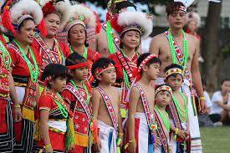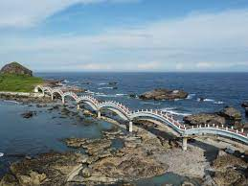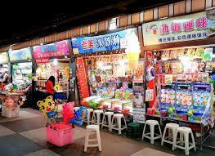

**Day 06 Hualien** (BLD)

Following breakfast, we embark on an excursion to **Taroko National Park**. Named after the Truku word for “magnificent”, Taroko National Park is one of Taiwan’s most beautiful sights. Created by the continual rising of the mountains combined with the erosive power of the Liwu River, **Taroko Gorge** is a true marvel to view. Next, we visit **Qixingtan Beac**h, a scenic crescent-shaped beach located in Xincheng Township. Instead of sand, Qixingtan Beach is covered in black and white pebbles that are perfectly smooth to the touch. Located next to Qixingtan, the **Chisingtan Katsuo Museum** is a museum with the theme of local fishing techniques and wood-fish production. At the end of the visit, you have the opportunity to purchase many different types of dried seafood. Back to Hualien for dinner at a local popular restaurant called **Mu Ming** that offers Michelin standard authentic and unique Taiwan aboriginal food.

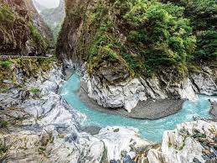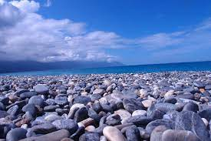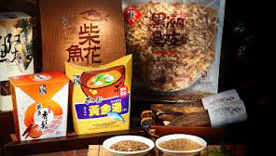

**Day 07 Hualien – Taipei** (BLD)

We check out after breakfast and board the **train to Taipei** (2.5hrs). We leave the East Rift Valley, a narrow strip of bucolic lowland between the Central Mountain Range and the Coastal Mountain Range for Taipei this morning. Arriving in Taipei, enjoy a city orientation tour. Check out century-old European architecture at **Dadaocheng** dating back from the Japanese colonial period. Don’t forget to finish off your day by visiting a famous **pineapple cake factory**! This evening after dinner you may like to visit the **Ximending Night Market**. We check into our hotel for overnight (Riverview Hotel or similar)

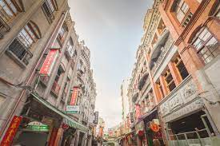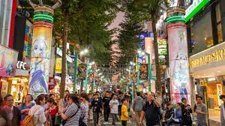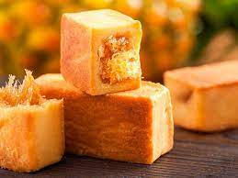

**Day 08 Taipei – Singapore** on SQ879 1735/2220hrs (B, meal on board)

After a leisure breakfast, explore on own before we depart for Taoyuan and transfer to the airport for our flight home later this afternoon reaching Singapore this evening.

NB: Choice of restaurants and routing may change in the event of closure due to prebooked events or uncontrollable conditions and shall serve as a guideline only.

**Flight Details**

SQ878 20FEB Tue Singapore/Taipei Dep 1125hrs Arr 1620hrs

SQ879 27FEB Tue Taipei/Singapore Dep 1735hrs Arr 2220hrs

|  |  |  |  |
| --- | --- | --- | --- |
| **8D/7N EAST TAIWAN**  **Price** | Twin Sharing PP  Member | Twin Sharing PP  Non-Member | Single  Member |
| 4-star hotels | **$2,240.00** | **$2,320.00** | **$2,690.00** |

Price includes:

* Return group airfare Singapore/Taipei/Singapore on Singapore Airlines
* Airport transfers
* Charter coach transportation with bottled drinking water
* 2-way train tickets
* 4-star hotel accommodation with breakfast (7 nights)
* All lunches and dinners (6 lunches, 7 dinners)
* Service of experienced tour manager, English speaking guide and driver
* Tipping for guide and driver
* All admissions and activity fees where required
* All local taxes

Price does not include - Personal incidentals, travel insurance

**CLOSING: 12 Dec with non-refundable deposit or when tour is full. Limited to 20 places max only!**